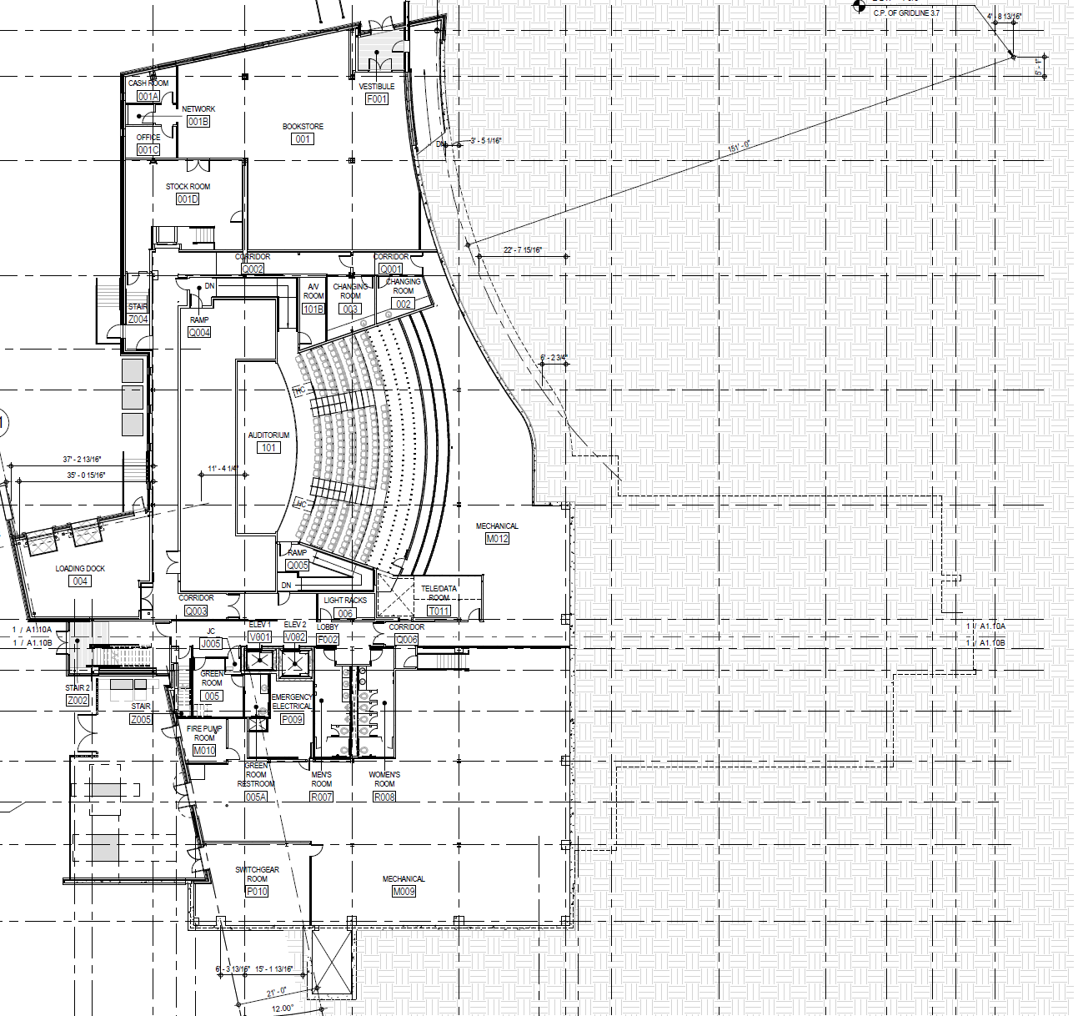

**SEC LOWER LEVEL**